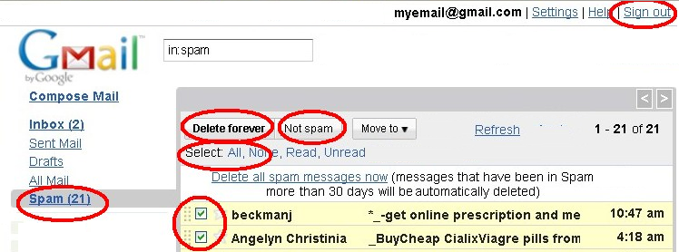GMAIL WEBMAIL
Are you having problems downloading your email? Are you missing some emails?
Then it is time to check our Webmail:
How to check your email anywhere around the world at any Internet shop or your laptop/PC:
If you have a gmail.com address:
Open this website inside Firefox
or Internet Explorer:
GMAIL.COM (type into the Address bar)
Type in your email address in “Username: _____”
and your password under “Password:______”.
Click “Sign In”
(Click on "HTML view" if it asks)
Click “All Mail” (on the left side)
Click “Spam” (on the left side)
Tick the emails you want recovered and click on "Not Spam"
Click "Sign out" (top right corner)
>Open your Outlook Express and click on "Send/Recv"
You will now receive your recovered emails.
Due to a huge amount of Spam Emails moving around in the world, your Gmail Email Account has an automatic Anti-Spam feature. Please note that some of your friends' or colleagues' emails might be accidentally blocked by the Gmail AntiSpam feature. The emails are still kept inside your Gmail online webmail spam-box for 30 days. To view or retrieve these emails you need to syphon them out..
i.e. You need to check your Gmail webmail account every 7 days.

When one receives too much junk mail/ spam, then you can report the emails by logging into GMAIL Webmail.
Click on "All Mail"
Then select the unwanted emails.
Then click on "Report Spam".

<<<<<<<<<>>>>>>>>>>>>>

MORE:
Information on Spam:
http://googleenterprise.blogspot.com/2009/01/2008-year-in-spam.html
If it takes too long to send or receive emails then your emails (or attachments) are too big. Please check your Outbox (Postausgang) for too big attachments.
Emails may not be bigger than 2000kb (2MB).
Karl can not be held liable should an email be erroneously blocked as SPAM.
Please do not send unsolicited bulk email.
For comments and ideas please contact Karl.

